DATA STRUCTURE
1. Consider an undirected graph G with 100 nodes. The maximum number of edges to be included in G so that the graph is not connected is
A) 2451
B) 4950
C) 4851
D) 9900
Answer: C
If a graph with n vertices has more than ((n - 1)*(n - 2))/2 edges then it is connecteD)

2. The amortized time complexity to perform ______ operation(s) in Splay trees is O(Ig n).
A) Search
B) Search & Insert
C) Search & Delete
D) Search, Insert & Delete
Answer: D
For m operations to be performed on splay tree it requires O(m log n) steps where n is the size of the tree. On an average the time complexity of each operation on the splay tree is Search: Searching for a node in the tree would take O(log n). Insert: Inserting a node in to the tree takes O(log n). Delete: Deleting a node from the tree takes O(log n).

3. Suppose that the splits at every level of Quicksort are in proportion 1-β to β, where 0 ‹ β ‹ = 0.5 is a constant. The number of elements in an array is n. The maximum depth is approximately
A) 0.5 β Ig n
B) 0.5 (1 − β) Ig n
C) β (Ig n)/(Ig β)
D) − (Ig n)/Ig (1 − β)
Answer: D
The minimum depth follows a path that always takes the smaller part of partition - i.e, that multiplies the number of elements by β . One iteration reduces the number of elements from n to β n , and i iterations reduces the number of elements to β i n . At a leaf, there is just one remaining element, and so at a minimum depth leaf of depth m, we have β mn=1.Thus, β m=1/n. Taking logs, we get m log β = - log n or m = - log n / log β .
Similarly, maximum depth corresponds to always taking the larger part of the partition, i.e., keeping a fraction 1 - β of the elements each time. The maximum depth M is reached when there is one element left, that is, when ( 1 - β) M n = . Thus, M = - lg(n) / lg(1 - β ).

4. The min. number of nodes in a binary tree of depth d (root at level 0) is
A) 2d − 1
B) 2d + 1 − 1
C) d + 1
D) d
Answer C
Counting the root node the minimum number of nodes will be d+1. this can be verified by taking either left or right skewed binary tree with any arbitrary depth D)

5. The efficient data structure to insert/delete a number in a stored set of numbers is
A) Queue
B) Linked list
C) Doubly linked list
D) Binary tree
Answer C
Because in case of doubly linked list only the node to be inserted/deleted needs to be manipulated and no traversals in forward or backward direction required for the operation so it is more efficient.

6. The most appropriate matching for the following pairs
X: depth first search 1: heap
Y: breadth-first search 2: queue
Z: sorting 3: stack
is (GATE CS 2000):
A) X—1 Y—2 Z-3
B) X—3 Y—1 Z-2
C) X—3 Y—2 Z-1
D) X—2 Y—3 Z-1
Answer: C
Stack is used for Depth first Search
Queue is used for Breadth First Search
Heap is used for sorting

7. The following numbers are inserted into an empty binary search tree in the given order: 10, 1, 3, 5, 15, 12, 16. What is the height of the binary search tree (the height is the maximum distance of a leaf node from the root)? (GATE CS 2004)
A) 2
B) 3
C) 4
D) 6
Answer: B
Constructed binary search tree will be..

10
/ \
1 15
\ / \
3 12 16
\
5

8. Level order traversal of a rooted tree can be done by starting from the root and performing (GATE CS 2004)
A) preorder traversal
B) in-order traversal
C) depth first search
D) breadth first search
Answer: D

9. Given the following input (4322, 1334, 1471, 9679, 1989, 6171, 6173, 4199) and the hash function x mod 10, which of the following statements are true?
i. 9679, 1989, 4199 hash to the same value
ii. 1471, 6171 has to the same value
iii. All elements hash to the same value
iv. Each element hashes to a different value
(GATE CS 2004)
A) i only
B) ii only
C) i and ii only
D) iii or iv
Answer: C

10. Which one of the following in place sorting algorithms needs the minimum number of swaps? (GATE CS 2006)
A) Quick sort
B) Insertion sort
C) Selection sort
D) Heap sort
Answer: C
For selection sort, number of swaps required is minimum ( θ (n) ).

11. The number of distinct minimum spanning trees for the weighted graph below is ____
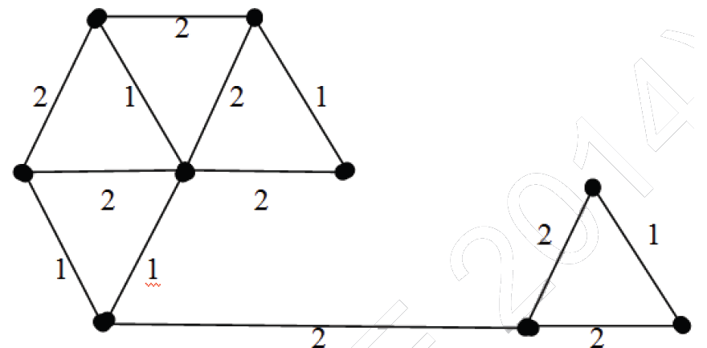

A) 10
B) 5
C) 6
D) 12
Answer: C
Highlighted (in green) are the edges picked to make a MST. In the right side of MST, we could either pick edge ‘a’ or ‘b’. In the left side, we could either pick ‘c’ or ‘d’ or ‘e’ in MST.
There are 2 options for one edge to be picked and 3 options for another edge to be pickeD) Therefore, total 2*3 possible MSTs.
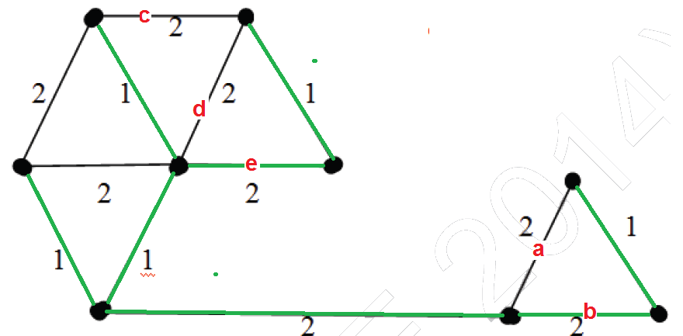

12. Consider the following rooted tree with the vertex P labeled as root 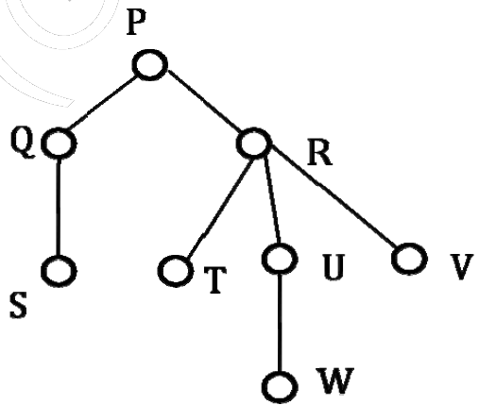
The order in which the nodes are visited during in-order traversal is
A)SQPTRWUV
B)SQPTURWV
C)SQPTWUVR
D) SQPTRUWV

Answer: A
The only confusion in this question is, there are 3 children of R. So when should R appear – after U or after R? There are two possibilities: SQPTRWUV and SQPTWURV. Only 1st possibility is present as an option A, the IInd possibility is not there. Therefore option A is the right answer.

13) Let A be a square matrix of size n x n. Consider the following program. What is the expected output?
C = 100
for i = 1 to n do
for j = 1 to n do
{
Temp = A[i][j] + C
A[i][j] = A[j][i]
A[j][i] = Temp - C
}
for i = 1 to n do
for j = 1 to n do
Output(A[i][j]);

A) The matrix A itself
B) Transpose of matrix A
C) Adding 100 to the upper diagonal elements and subtracting 100 from diagonal elements of A
D) None of the above

Answer: A
If we take look at the inner statements of first loops, we can notice that the statements swap A[i][j] and A[j][i] for all i and j.
Since the loop runs for all elements, every element A[l][m] would be swapped twice, once for i = l and j = m and then for i = m and j = l. Swapping twice means the matrix doesn’t change.

14) The minimum number of arithmetic operations required to evaluate the polynomial P(X) = X5 + 4X3 + 6X + 5 for a given value of X using only one temporary variable.
A) 6
B) 7
C) 8
D) 9
Answer: B
We can parenthesize the polynomial to minimize the number of operations. We get X(X2(X2 + 4) + 6) + 5 after parenthesization.
Following is sequence of operations to be useD)
Note that we are allowed to use only one variable.
res = X*X
res = res + 4
res = X*res
res = X*res
res = res + 6
res = X*res
res = res + 5

15) You have an array of n elements. Suppose you implement quicksort by always choosing the central element of the array as the pivot. Then the tightest upper bound for the worst case performance is

A)O(n2)
B)O(nLogn)
C)Θ(nLogn)
D) O(n3)
Answer: A
The middle element may always be an extreme element (minimum or maximum) in sorted order, therefore time complexity in worst case becomes O(n2)

16.The following postfix expression with single digit operands is evaluated using a stack:
8 2 3 ^ / 2 3 * + 5 1 * -
Note that ^ is the exponentiation operator. The top two elements of the stack after the first *is evaluated are:
A) 6, 1
B) 5, 7
C) 3, 2
D) 1, 5
Answer: A
Symbols read so far Operand stack
8 8
8 2 8 2
8 2 3 8 2 3
8 2 3^ 8 8
8 2 3^/ 1
8 2 3^/2 1 2
8 2 3^/2 3 1 2 3
8 2 3^/2 3 * 1 6
17.Consider the following C function:
int f(int n)
{
static int are = 0;
If (n < = 0) return 1;
If (n > 3)
{ r = n;
return f (n – 2) + 2;
}
return f(n – 1) + r;
}
What is the value of f(5)?
A) 3
B) 7
C) 9
D) 18
Answer: D
f(5) will return f(3)+2
f(3) will return f(2)+5
f(2) will return f(1)+5
f(1) will return f(0)+5
f(0) will return 1
f(1) will return 6
f(2) will return 11
f(3) will return 16
f(5) will return 18

18. Suppose you are given an implementation of a queue of integers. The operations that can be performed on the
queue are:
isEmpty(Q) – returns true if the queue is empty, false otherwise.
delete(Q) – deletes the element at the front of the queue and returns its value.
insert(Q, i) – inserts the integer i at the rear of the queue.
Consider the following function:
void f(queue Q)
{
int i;
if(!isEmpty (Q)) {
i = delete(Q);
f(Q)
insert(Q, i);
}
}
What operation is performed by the above function f?
A) Leaves the queue Q unchanged
B) Reverse the order of elements in the queue Q
C) Deletes the element at the front of the queue Q and inserts it at the rear keeping the other elements in the same order
D) Empties the queue Q.
Answer: B
Due to recursion the last element deleted will be the first to be inserted so element that was at rear will be at front in new queue and the second last element will be at second position hence the queue will be reverseD)

19. Consider the following C program:
#include<stdio.h>
#define EOF -1
void push(int); /* Push the argument on the stack */
int pop(void); /* pop the top of the stack */
void flagError();
int main( )
{ int c, m, n, r;
while ((c = getchar( )) != EOF)
{ if (isdigit(c))
push (c)
else if (c = = ‘+’) || (c = = ‘*’))
{ m = pop( );
n = pop( );
are = (c = = ‘+’) ? n + m : n*m;
push(r);
}
else if (c != ‘ ‘)
flagError( );
}
printf(“%c”, pop( ));
}
What is the output of the program for the following input?
5 2 * 3 3 2 + * +
A) 15
B) 25
C) 30
D) 150
Answer: B
Sequence of operations will be
1. push(5)
2. push(2)
3. m = 2;n=5 ;r=5*2
4. push(r) /*push(10)*/
5. push(3)
6. push(3)
7. push(2)
8. m=2; n= 3;r=3+2
9. push(r) /* push(5)*/
10. r=5*3
11. push(r) /*push(15)*/
12. m=15;n = 10;r=15+10
13. push(r)
14. printf(“%d”,pop());
Which will print 25

20. Suppose you are given an implementation of a queue of integers. The operations that can be performed on the
queue are:
isEmpty(Q) – returns true if the queue is empty, false otherwise.
delete(Q) – deletes the element at the front of the queue and returns its value.
insert(Q, i) – inserts the integer i at the rear of the queue.
Consider the following function:
void f(queue Q)
{
int i;
if(!isEmpty (Q)) {
i = delete(Q);
f(Q)
insert(Q, i);
}
}
What operation is performed by the above function f?
A) Leaves the queue Q unchanged
B) Reverse the order of elements in the queue Q
C) Deletes the element at the front of the queue Q and inserts it at the rear keeping the other elements in the same order
D) Empties the queue Q.
Answer: B
Due to recursion the last element deleted will be the first to be inserted so element that was at rear will be at front in new queue and the second last element will be at second position hence the queue will be reverseD)

21. Following is C like pseudo code of a function that takes a number as an argument, and uses a stack S to do processing.
void fun(int n)
{
Stack S; // Say it creates an empty stack S
while (n > 0)
{
// This line pushes the value of n%2 to stack S
push(&S, n%2);

n = n/2;
}

// Run while Stack S is not empty
while (!isEmpty(&S))
printf("%d ", pop(&S)); // pop an element from S and print it
}

What does the above function do in general?
A) Prints binary representation of n in reverse order
B) Prints binary representation of n
C) Prints the value of Logn
D) Prints the value of Logn in reverse order

Answer: B

See method 2 of https://www.geeksforgeeks.org/binary-representation-of-a-given-number/ for explanation.

22.Which one of the following is an application of Stack Data Structure?
A) Managing function calls
B) The stock span problem
C) Arithmetic expression evaluation
D) All of the above
Answer: D
Explanation: See http://en.wikipediA)org/wiki/Stack_(abstract_data_type)#Applications

23. Which of the following is true about linked list implementation of stack?
A) In push operation, if new nodes are inserted at the beginning of linked list, then in pop operation, nodes must be removed from enD)
B) In push operation, if new nodes are inserted at the end, then in pop operation, nodes must be removed from the beginning.
C) Both of the above
D) None of the above
Answer: D
To keep the Last In First Out order, a stack can be implemented using linked list in two ways:
a) In push operation, if new nodes are inserted at the beginning of linked list, then in pop operation, nodes must be removed from beginning.
b) In push operation, if new nodes are inserted at the end of linked list, then in pop operation, nodes must be removed from enD)

24. Consider the following pseudocode that uses a stack
declare a stack of characters
while ( there are more characters in the word to read )
{
read a character
push the character on the stack
}
while ( the stack is not empty )
{
pop a character off the stack
write the character to the screen
}
What is output for input "geeksquiz"?
A) geeksquizgeeksquiz
B) ziuqskeeg
C) geeksquiz
D) ziuqskeegziuqskeeg
Answer: B
Since the stack data structure follows LIFO order. When we pop() items from stack, they are popped in reverse order of their insertion (or push())

25. Following is an incorrect pseudocode for the algorithm which is supposed to determine whether a sequence of parentheses is balanced:
declare a character stack
while ( more input is available)
{
read a character
if ( the character is a '(' )
push it on the stack
else if ( the character is a ')' and the stack is not empty )
pop a character off the stack
else
print "unbalanced" and exit
}
print "balanced"

Which of these unbalanced sequences does the above code think is balanced?
A) ((())
B) ())(()
C) (()()))
D) (()))()
Answer: A
At the end of while loop, we must check whether the stack is empty or not. For input ((()), the stack doesn’t remain empty after the loop. See https://www.geeksforgeeks.org/check-for-balanced-parentheses-in-an-expression/ for details.

26) Any node is the path from the root to the node is called
A) Ancestor node
B) Successor node
C) Internal node
D) None of the above
Answer: A

27) Which of the following is not the type of queue?
A) Priority queue
B) Circular queue
C) Single ended queue
D) Ordinary queue
Answer: C

28) A graph is a collection of nodes, calleD)..... And line segments called arcs or ...... that connect pair of nodes.
A) vertices, paths
B) vertices, edges
C) graph node, edges
D) edges, vertices
Answer:B
29) Herder node is used as sentinel in........
A) Queues
B) Stacks
C) Graphs
D) Binary tree
Answer:D

30) Two main measures for the efficiency of an algorithm are
A) Processor and memory
B) Complexity and capacity
C) Time and space
D) Data and space
Answer: C

31) The time factor when determining the efficiency of algorithm is measured by
A) Counting microseconds
B) Counting the number of key operations
C) Counting the number of statements
D) Counting the kilobytes of algorithm
Answer: B

32) The space factor when determining the efficiency of algorithm is measured by
A) Counting the maximum memory needed by the algorithm
B) Counting the minimum memory needed by the algorithm
C) Counting the average memory needed by the algorithm
D) Counting the maximum disk space needed by the algorithm
Answer: A

33) The Worst case occur in linear search algorithm when
A) Item is somewhere in the middle of the array
B) Item is not in the array at all
C) Item is the last element in the array
D) Item is the last element in the array or is not there at all
Answer: D

34) The Average case occur in linear search algorithm
A) When Item is somewhere in the middle of the array
B) When Item is not in the array at all
C) When Item is the last element in the array
D) When Item is the last element in the array or is not there at all
Answer: A

35) The complexity of the average case of an algorithm is
A) Much more complicated to analyze than that of worst case
B) Much more simpler to analyze than that of worst case
C) Sometimes more complicated and some other times simpler than that of worst case
D) None or above
Answer: A

36) The complexity of linear search algorithm is
A) O(n)
B) O(log n)
C) O(n2)
D) O(n log n)
Answer: A

37) The complexity of Binary search algorithm is
A) O(n)
B) O(log )
C) O(n2)
D) O(n log n)
Answer: B

38) The complexity of Bubble sort algorithm is
A) O(n)
B) O(log n)
C) O(n2)
D) O(n log n)
Answer: C

39)The complexity of merge sort algorithm is
A) O(n)
B) O(log n)
C) O(n2)
D) O(n log n)
Answer: D

40) The indirect change of the values of a variable in one module by another module is called
A) internal change
B) inter-module change
C) side effect
D) side-module update
Answer: C

41) The elements of an array are stored successively in memory cells because
A) by this way computer can keep track only the address of the first element and the addresses of other elements can be calculated
B) the architecture of computer memory does not allow arrays to store other than serially
C) both of above
D) none of above
Answer: A

42) Each array declaration need not give, implicitly or explicitly, the information about
A) the name of array
B) the data type of array
C) the first data from the set to be stored
D) the index set of the array
Answer: C

43) Which if the following is/are the levels of implementation of data structure
A) Abstract level
B) Application level
C) Implementation level
D) All of the above
Answer: D

44) 2. A binary search tree whose left subtree and right subtree differ in height by at most 1 unit is called ……
A) AVL tree
B) Red-black tree
C) Lemma tree
D) None of the above
Answer: A

45) 3. ……………….. level is where the model becomes compatible executable code
A) Abstract level
B) Application level
C) Implementation level
D) All of the above
Answer:C

46) 5. Which of the following is true about the characteristics of abstract data types?
i) It exports a type.
ii) It exports a set of operations
A) True, False
B) False, True
C) True, True
D) False, False
Answer:C

47) 6. …………… is not the component of data structure.
A) Operations
B) Storage Structures
C) Algorithms
D) None of above
Answer:D

48) 7. Which of the following is not the part of ADT description?
A) Data
B) Operations
C) Both of the above
D) None of the above
Answer:D

49) 8. Inserting an item into the stack when stack is not full is called …………. Operation and deletion of item form the stack, when stack is not empty is called ………..operation.
A) push, pop
B) pop, push
C) insert, delete
D) delete, insert
Answer:A
50) 10. ………… is very useful in situation when data have to stored and then retrieved in reverse order.
A) Stack
B) Queue
C) List
D) Link list
Answer:A

